Road Safety Guard

Operation Instruction
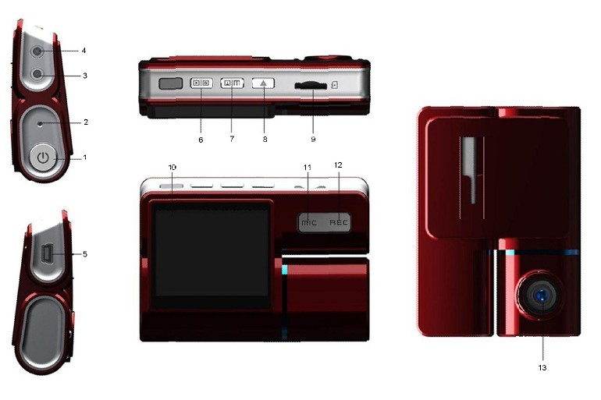
Key Operation :
1. Power on/off
2. Reset
3. Camera 1
4. Camera 2
5. USB
6. Menu
7. Mode/Photo
8. OK
9. TF Card
10. LCD Display screen
11. MUTE/UP
12. REC/DOWN
13. Flashlight

Menu operating instructions

Video recording Mode

In the Video recording Mode, Press “Menu” button enter Setup interface.
Press UP/Down button to select specific parameters, Press “OK” to confirm and Press “Menu” to Exit.

1. Video Resolution

HD 1280*720
D1 720*480
VGA 640*480

2. Camera

Select camera to recording, camera 1/camera 2/ camera 1+2

3. Time Stamp

Off No display date and time
Date Only Only display date
Date and Time Display date and time

4. Voice setup

On Turn on Voice Prompt
Off Turn off Voice Prompt

5. REC Sound

Off Video recording turn off the sound
On Video recording sound and image sync
4. G-sensitivity

Setting G-sensor sensitivity, Off/ high/Medium/Low
When happen impact the video file will protect and the file name is (EVE.XXXXX) ,the card is full only delete normal recording file (REC.XXXXX).

7. Brightness

Set camera 1/camera 2 brightness

Photo mode

Power on the camcorder, press “ Photo ” button to capture pictures.
photo will auto save to TF card

Setting Mode

In the other Mode, Press “Menu” button twice enter Setup interface.
Press UP/Down button to select specific parameters, Press “OK” to confirm and Press “Menu” to Exit.

1. Format

Format TF Card (Select “Execute “format TF Card )

2. Screensaver

Off Camera LCD keep on
1 Min If no any operating the camera after 1min enter screensaver
3 Min If no any operating the camera after 3min enter screensaver
5 Min If no any operating the camera after 5min enter screensaver
（Screensaver status ,Press any button to restore）

3. Beep

On Turn On operation button sound
Off Turn off operation button sound

4. Language

English/ French/ Deutsch/Italian/Spanish/Portuguese / T-Chinese/ S-Chinese/ Russian/ Turkish/Korean
5. Auto off

Off Camera not auto power off
1 Min If no any operating the camera after 1min auto power off
3 Min If no any operating the camera after 3min auto power off
5 Min If no any operating the camera after 5min auto power off

6. Sys. Reset

When Setup Error, can setting this option restore factory setting

7. Light Frequency

50HZ
60HZ

8. Date Input

1）Press “Up”/Down button to setting number
2）Press “Mode” button jump next setting
3）Press “REC” button Exit set

9. Version

Check software version information

Playback Mode

Press “Mode” button change to Playback mode (Press “OK” button to playback the video file)

- Press Up/Down button to select previous/next video /photo file
- Press “OK” Play/Stop

1. Delete

Single Delete single file
All Delete all the file

2. Protect

Single Delete single file
All Delete all the file

3. Thumbnail /Execute

4. File List /Execute

5. Volume

Adjust volume 1~8

Loop Recording

When TF Card is full ,the camera will auto delete in front of the old files, When happen impact the video file will protect(EVE.XXXXX) ,the card is full only delete normal recording file (REC.XXXXX).

Flashlight function

Camera in the power off or other mode, short Press power button to turn on flashlight, press again turn off .

Parking Mode

When the car in the stop status, after 3 minute will auto change to parking mode, in the parking mode the video file is 1FPS

Note:
1) According the need of customers, this function is options.

2) In order to avoid the improper operation to install damage the camera , Please to auto service center to find a professional maintenance technicians to install, and use package accessory special cable（DC Input:12-24 V Output :5V-1.5A）

Connect Computer
1. Connect the camcorder with computer by USB cable, [My computer] will occur removable disk, the file id stored at Removable Disk/DCIM/100DSCIM which can be downloaded to the computer.
2. System support of the Computer: Windows 2000/XP/Vista/Windows 7

Power on test

1）First time use camera ,please use package accessory USB cable connect to charger（DC-5V 1A）, then connect to USB slot, power on test normal recording and other function
2）After power on test normal, can install and use

Charging the battery
1. Directly connect car cigarettes with the USB interface, to charge battery
2. Use a USB cable to connect the computer with the USB interface, to charge battery
3. Use the USB cable to connect charger the USB interface, to charge battery.
4. The battery level display shows the remaining power of the battery as below:
Low power Not fully charged fully charged

TF card installment :

- insert the TF card in the TF Card slot according to the indicative direction ,until it softly clicks
2. When removing the TF card push in the TF card and gently release to eject it.
Notes:
- Make sure the TF card are facing the right way ,if it is in the wrong direction ,it may damage the camera and TF card
- If the TF card is incompatible with the camera, please try to insert again ,change other TF card
- Please use the high- speed TF card. （The card have CLASS⑩ icon）

Notice:
Suppose the camera is in dead halt due to the improper operation, you can press reset button to restore the camera will return to normal

Technical specifications

LCD screen | 2.0 TFT
Camera lens | 120 degrees A+ level high resolution lens
Language | English/ French/ German /Italian/Spanish/Portuguese / T-Chinese/ S-Chinese/ Russian/ Turkish
Video format | AVI (MJPG)
Resolution | 2M
Photo format | JPG
Memory card | TF（256MB-32GB）
Microphone | Built–in
Capture mode | Single
Frequency | 50Hz/60Hz
USB interface | USB2.0
Battery | Built-in
G-SENSOR | Support
System | Windows 2000/XP/Vista/windows 7

Notice: Due the camera software update camera function has change, without prior notice

