**Instrument status list**

|  |  |  |  |  |  |
| --- | --- | --- | --- | --- | --- |
| **客户名称** | |  | | Instrument name | MLS003 instrument |
| No. | project | | | Function parameter | |
|  | Operating Voltage | | | **DC12V。** | |
|  | Standby power consumption after power off | | | Less than 4mA. | |
|  | **Speedometer** | | | Liquid crystal display, 76Hz=60KM/H; maximum display 299KM/H. | |
|  | Tachometer | | | 166Hz to 10×1000r/min, more than 10×1000r/min alarm light is on.  Maximum 19×1000r/min. | |
|  | Fuel gauge | | | Liquid crystal display, E point 98Ω, F point 8Ω. | |
|  | Water temperature meter | | | Switch type, connected to 12V negative, lights. | |
|  | Voltmeter | | | Below 9.0V under-voltage light, above 9.5V off. | |
|  | button | | | **A, short press the right key, cycle switching ODO, TRIP, MAX three states.**  **B. In the TRIP state, long press the right button and TRIP is cleared.** | |
|  | **clock** | | | **24-hour clock, display format, 00:00. Turn off the clock display, seconds do not flash. The seconds will flash when you open the door.**  **Long press the left button, the clock hours bit flash, short press the left button plus 1, then long press the left button to switch to the sub-bit flash, short press the left button to add 1, then long press the left button to exit. (Regardless of subtotal or total can enter the clock debug)** | |
|  | **Backlight** | | | **7 colors, in the ODO state, long press the right button to switch, the factory default is blue.**  **The backlight switches in order: blue, purple, red, yellow-green, green, light blue, white.** | |
|  | **LCD screen** | | | 6 o'clock. | |
|  | **sensor** | | | **CY1910 OSH M12 magnetic sensor.** | |
|  |  | | **Green blue: water temperature**  **Black: switch**  **Orange: turn left, 12V is controlled, light green**  **Light blue: Turn right, 12V is controlled, light green**  **Purple: Battery（Hold clock, connect to battery positive）**  **Yellow/White: Fuel**  **Blue: High beam,**  **Green: negative**  **Black/yellow: RPM** | | |
|  |  | | **Pink: 1 gear**  **Blue/Red: 2 gear**  **Green/Black: 3 gear**  **Yellow/Red: 4 gear,**  **Brown / white: 5 gear**  **Red/White: 6 gear**  **Green/Red: N gear**  **Brown/Red: Engine** | | |
|  |  | | **Red: sensor signal**  **Yellow: sensor positive**  **Green: sensor negative** | | |

**Background settings：**

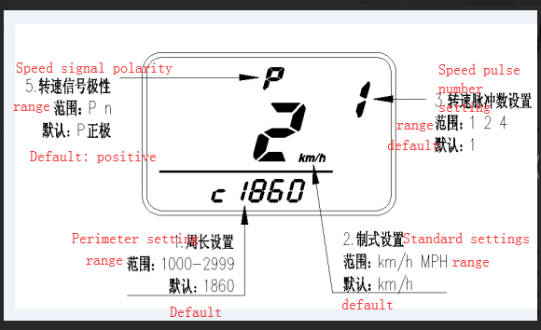 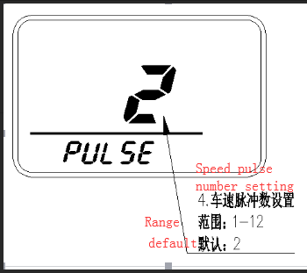

**1. Background setting: Left and right keys are pressed at the same time to enter the background setting, the order is: perimeter - system - speed pulse number - speed pulse number - speed signal polarity, short press the right button to exit.**

**2. The first bit of the perimeter is flashing. Short press the left button to modify. Adjust the range 1-2. Press the right button to move to the second position. The adjustment range is 0-9. Short press the left button to modify, and then press the right button to move. To the third position, the adjustment range is 0-9. Press the left button to modify it, and then press the right button to move to the fourth position. The adjustment range is 0-9. Short press the left button to modify.**

**3. Short-press the right button again to switch to the system, press the left button to modify the system, metric (KM/H) or imperial (mph), the default is metric.**

**4. Short-press the right button again to switch to the number of speed pulses. Short press the left button to modify. The adjustment range is 1 (166Hz for 10×1000RPM), 2 (332Hz for 10×1000RPM), and 4 (664Hz for 10×1000RPM).**

**5. Short-press the right button again to switch to the number of vehicle speed pulses. Short press the left button to modify. The adjustment range is 1-12.**

**6. Short press the right button again to switch to the polarity of the speed signal. Short press the left button to modify. P positive pulse, n negative pulse, the default is P.**

**7. Short-press the right button again to exit the background setting, or save the background setting without saving the operation within 5 seconds.**

**The instrument is a precision device. If you don't know how to install or encounter any problems, please contact customer service first. Customer service will help you solve the problem. Please don't open the dispute in a hurry. Thank you for your understanding.**